Safeguard System to monitor and prevent damages of impaired Automobiles

# ABSTRACT

In the recent years, smart sensing approach creating a vibrant impact in shaping our future. Recent technological advancement which has influenced a change in lifestyle is the field of IOT. IOT is the internetworking of physical devices, and other devices embedded with the electronics, software, sensors and network connectivity that enable to get data of those objects. In India transportation is a booming field where the count of vehicles increasing day by day. Monitoring vehicle parameters like fuel, temperature, Battery level, speed is an ideal to know without making any physical touch of the vehicle. Digital locking system is a much needed one in this digital domain. Tracking of our vehicle is also a vital one when your vehicle is not with you. Here the tracking of vehicle is developed by using GPS to locate the user’s vehicle easily. IOT cloud based real time automobile monitoring system is a capable one which leads to monitor our vehicle’s parameters such as fuel level, battery level, engine temperature and speed along with this monitoring alcohol percentage of driver through android application, if this parameter exceeds particular level, we get alert notification. It’s Smart RFID digital key secure your vehicle more than by accessing by keys. In this project we can save our vehicle documents, user driving license, insurance copy and other documents in android application. Immediate sending Message with location to trusted persons whenever ensue accidents.

The proposed system plays an important role in real time tracking and monitoring of vehicle and also provides safety and secure solution to the traveller using sensors. Whenever there is a vehicle theft situation or accident situation, the proposed system provides the vehicle’s current location, speed to the vehicle owner’s mobile. Hence it is a benefit to track the vehicle as early as possible.

# Block Diagram

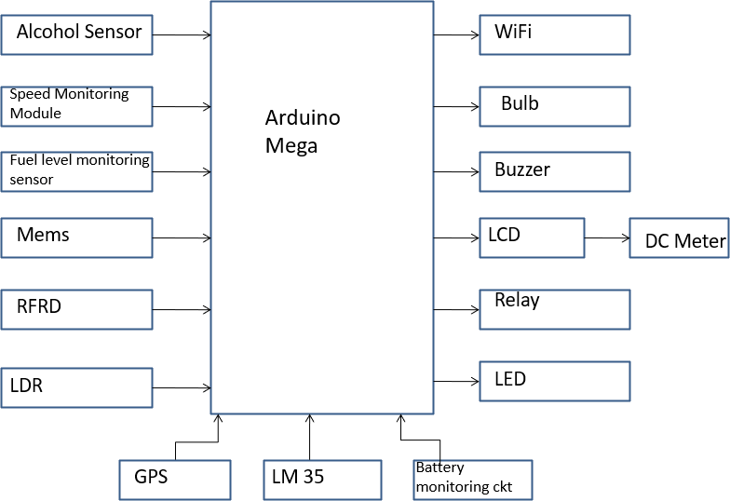

HARDWARE COMPONENTS:

* Arduino Mega
* LDR
* Speed Monitoring Module
* LM 35
* Alcohol sensor
* GPS sensor
* MEMS sensor
* Fuel level monitoring sensor
* RFRD ignition module
* LCD display
* WIFI module
* Buzzer
* Bulb
* DC Meter
* Relay
* LED
* Battery monitoring circuit

# SOFTWARE COMPONENTS:

* Embedded c
* Arduino IDE

References:

1. L. Atzori, A. Iera, and G. Morabito, “The Internet of Things: A Survey, ”Computer Networks, vol. 54, no. 15, pp. 2787–2805, 2010.
2. E. A. Lee, “Cyber Physical Systems: Design Challenges,” in Object Oriented Real-Time Distributed Computing (ISORC), 2008 11th IEEE International Symposium on. IEEE, 2008, pp. 363–369.
3. A. Zanella, N. Bui, A. Castellani, L. Vangelista, and M. Zorzi, “Internet of Ihings for Smart Cities,” Internet of Things Journal, IEEE, vol. 1,no. 1, pp. 22–32, 2014. [4] “Digital India,” Online, 2015, (Last accessed March 18, 2016). [Online]. Available: <http://www.digitalindia.gov.in/>

INTERNAL GUIDE: Batch No: C16

M. Krishna Chaithanya 18321A04G1-K. Susmitha

Assistant Professor 18321A04G2-B. Susritha

18321A04H3-S. Vaishanvi